**Automate the Boring Stuff with Python Programming**

**Section 3. Functions**

**None return type**

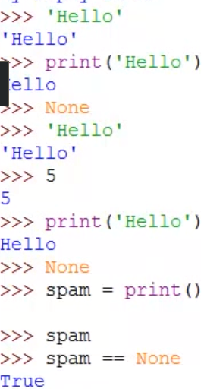

print returns a special type of value of data type None

every function has a return value (print has None, by default it is None)

**Global and Local Variable**

Rule 1: Code in the global scope cannot use any local variables

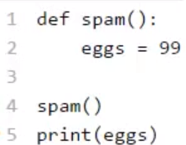



Rule 2: Code in a local scope can access global variables

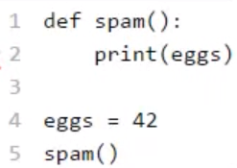 output: 42

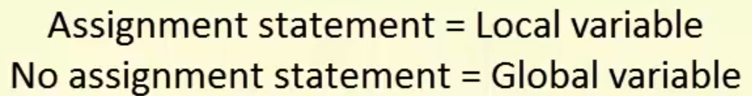

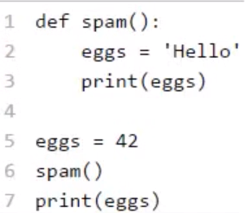output: Hello 42

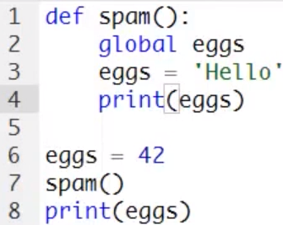 output: Hello Hello

Rule 3: Code in one function’s local scope cannot use variables in another local scope

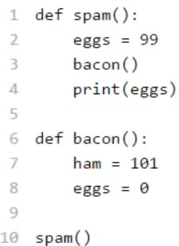 output: 99

**Section 9. Run programs on cmd**



